**2024 EMEA Align Collaborative Research Proposal Template**

(All sections should be filled out as completely as possible)

**Cover Page**

This information is used to contact the investigator or the institution should any questions arise. The payment section is used to facilitate payment issuance should the proposal be selected to receive an Align Research Award. Applicant should replace *italicized* information with study-proposal information.

|  |  |
| --- | --- |
| Primary Investigator | **Name:**  **University Name**:  **Address:**  **Phone:**  **Email:** |
| Co-Investigator(s) | **Name:**  **University Name:**  **Address**:  **Phone**:  **Email**: |
| Co-Investigator(s) | TBC |
| Consultants | Name:  University Name:  Address:  Phone:  Email: |

**Proposal Content**

*Title:*

1. **Abstract**
2. **Hypothesis (required)**

*Applicants* ***must*** *state precisely and clearly the question(s) that the research will attempt to answer and any hypotheses to be tested. If this part is left blank, the application may be dropped from consideration by the review committee.*

1. **Study Objectives / Study Aim**

.

1. **Study Design**

* *Study design description*
* *Patient inclusion/exclusion criteria*
* *Sample size calculation- Number of patients to be included in the study*
* *Study Objectives*
* *Primary endpoint /secondary endpoint*
* *Treatment protocol*
* *Timepoints (baseline, 9months follow up, etc..)*
* *Outcomes & Measurements including details how are the conducted*
* *Include questionnaires if applicable (patients satisfaction or quality of life questionnaires*
* *Data collection, how it will be the data collected and analyse*
* *Statistical methods and analysis*
* *Ethical Approval Information*
* *Publication plan*
* *Study Tiemlines (from First patient in to last patient last follow up) see example below*

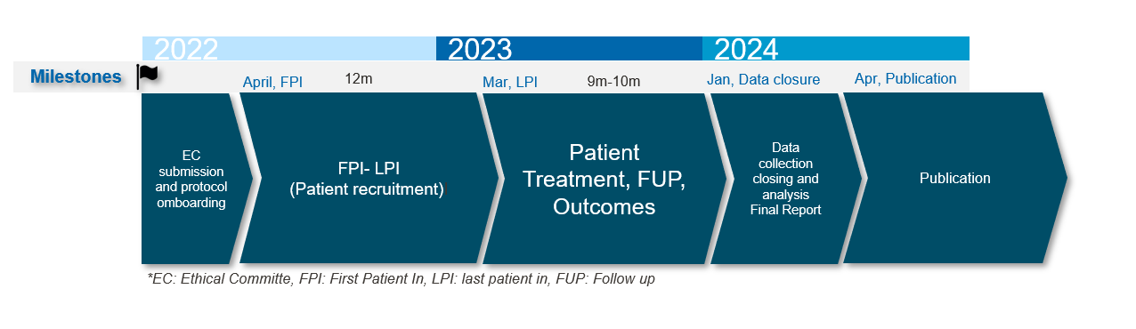

1. **Budget and Justification**

For this research we would like support with ……

1. **Qualification of Application**

Explain Drs Qualifications to conduct the study. Degrees and affiliation

1. **Biographical Sketch (C.V.) and Role of Investigators**
2. **References**

* -